Darren Jones MP
Chair, Business, Energy and Industrial Strategy Committee
House of Commons
London
SW1A 0AA

By email: beiscom@parliament.uk

8 December 2022

Dear Darren,

THE DECARBONISATION OF THE POWER SECTOR
Thank you for your letter of 29 November. Equinor is happy to support your enquiry. You and your committee will appreciate that some of the questions you have posed are ones we will not be able to answer, due to rules of commercial confidence. We have done our best to answer what we can.

Tax payments

Equinor is the second highest tax paying company in the world, and in 2021 paid a global total of $8.9bn in corporate income taxes and $2.9bn in royalty payments and fees to local and national governments including host entitlement. In the UK, as in other jurisdictions where we operate, we pay tax on our net profits according to the local tax rules as a company (i.e. tax is not paid on a project or joint venture basis). In the UK we have invested heavily in energy projects in recent years, from the Mariner oil field with a gross investment of $7.7bn that came onstream in 2019, to offshore wind investments such as Dogger Bank, the world’s largest offshore wind farm, which will come on-line in 2023. These investments are deducted against tax, and our tax payments in the UK are affected accordingly. Our 2022 Tax report is available here (link). As the BEIS committee is fully aware, projects in the energy sector often take many years to plan and to build, and then operate for decades, so a single-year snapshot of tax payments does not give an accurate picture of either taxes paid, or the benefits projects bring to the economy. According to our internal assessments, we expect to be paying tax resulting from the energy profits levy as introduced by the UK government in May and then amended in November.

Rosebank

We are still assessing the impacts of the new energy profits levy as announced by the UK government in November, and there are some details that need to be clarified in the legislation before it comes into force. One key factor for this new levy will be its duration. At present the UK Government has said that it should end in 2028. The Labour Party has indicated that the tax level will be raised, the investment allowances cut, and that they too expect it to end in 2028, but the end date is not certain. The new levy, and different governments’ approaches to it, will have an impact on the business case for the Rosebank project, and on the tax the joint venture partners would pay, should the project go ahead. Each owner in Rosebank must justify their company’s investment in the UK, compared with other oil and gas projects around the world. Potential suppliers will also make similar assessments. We understand that the energy profits levy was introduced against a backdrop of high commodity prices and a cost of living crisis. Equinor appreciates and recognises the effect this has on society and individuals and, hence, the notion that businesses need to contribute, support and work with government to minimise the impact. However, commodity prices, which formed the bases for the levy introduction, are now at pre-war levels (Brent traded at $77.17 today) and the forward price model held by corporations and financial institutions in the levy window up to 2028 may be even lower than this. The combination of higher tax and low commodity price forecast assumptions for the medium term is likely to impact investment negatively. That is why we believe a price floor, at which the EPL would cease, would be helpful to increase investor confidence in the oil and gas sector. The new levy on renewable energy generation will also have an impact on current and potential future projects in the UK.

As we have announced, direct investment over the lifetime of the field (CAPEX and OPEX) into the Rosebank project, if approved, would be around £8.1bn. By way of comparison, in 2020-21 the UK attracted just under £4bn of international investment in total. (Department for International Trade inward investment results 2020 to 2021 (HTML version) - GOV.UK (www.gov.uk)) The Energy Profits Levy (also referred to as windfall tax) introduced by the UK government in the summer of 2022 is an additional tax, paid over and above the corporate and supplementary taxes already paid by the oil and gas industry in the UK. It includes an investment allowance, but even with the investment allowance, the Wood Mackenzie report on Rosebank issued in August 2022 estimated that over the lifetime of the project £2.7bn would be paid to the UK government in tax. In addition to the tax that would be paid on Rosebank, it is estimated by Wood Mackenzie that an additional £24.1billion would be generated in gross value add, alongside 1,200 UK based jobs at the peak of activity.

With demand for oil and gas in the UK projected to outstrip supply until 2050, the alternative to domestic oil and gas is imports, which would result in a loss of cashflow to the UK and increased emissions, given that imported oil has a higher CO2 footprint. Our Rosebank project is already planned to be one of the most carbon efficient field developments in the UK from first production. Electrification would take emissions from production down to just 3kg per barrel, less than 15% of the UK average.

Renewables and Low Carbon Investment in the UK

As stated above, it is not appropriate to look at one financial year in isolation when considering long term business investment in the energy sector. For example, we are in the midst of the construction of Dogger Bank, the world’s largest offshore windfarm, together with our partners SSE. The total investment in this project is around £9bn, but the construction began in 2019 and will continue into 2023 and beyond as the windfarm is developed, with the first power of the first phase of the farm coming on-line in 2023.

In the Humber, where we are investing in the low carbon businesses of carbon capture, usage and storage (CCUS) and hydrogen to decarbonise the UK’s largest industrial cluster, our projects include investment in hydrogen manufacturing, power with carbon capture and storage, CO2 pipelines and underground storage, and hydrogen pipelines and underground storage. Although we are preparing final investment decisions on these for approval at the end of 2023 or early 2024, then leading to the building of the projects from 2024 onwards, those decisions will depend on the UK government making progress on the CCUS and hydrogen business cases and funding. In the meantime, however, we are investing in the UK in preparation for those decisions, with our largest single investment this year being the purchase of Triton Power, together with SSE. The key facility included in the purchase is the Saltend Power Station, which will be one of the power stations to convert to hydrogen in the coming years.

Looking ahead, Equinor also intends to invest in the Celtic Sea for floating offshore wind, in Norfolk to extend our two existing windfarms, in Peterhead for power with carbon capture and storage, and in Teesside. We have also invested in the UK battery company Noriker Power Ltd, and have an active ventures arm that invests globally in new energy businesses. At the global level, Equinor’s largest investments in offshore wind thus far have been in the UK, and its largest plans for investment in CCUS and hydrogen are also in the UK. At the corporate level Equinor will invest at least 50% of its capex in renewables and low carbon businesses by 2030. In 2022 alone, we have doubled our share of gross investment into renewables to 20 percent.

As of its Q1 2021 annual report, Equinor has reported green revenues quarterly as a separate segment in its financial reporting. However, as set out above, investment in all energy projects is long term and subject to long lead times, both for projects under construction and those developed through mergers and acquisitions activity. As such, we see that guidance on renewable investment plans over a multiyear time horizon is of more value to external stakeholders than on a quarterly basis.

Oil and gas in the global energy mix

Please see Equinor’s Energy Perspectives analysis for 2022 (Energy Perspectives 2022 - Equinor). This sets out our expectations for the global future energy mix up to 2050, with a shrinking role for oil and gas and a growing role for renewable and low carbon businesses.

The IEA’s 2021 Net Zero Emissions scenario to which you refer in your letter was based on a model that assumed global energy demand would decline at a rate sufficient to achieve a 1.5-degree trajectory: equivalent to around a 30% decrease to 72 million barrels per day (mbpd) in 2030. The IEA’s own analysis from October 2022 shows that global oil demand is expected to grow next year by 1.7 million barrels per day to over 101mbpd, even as the world attempts to reduce its reliance on Russian energy. One day the world will no longer need oil and gas. But for as long as we do, it is vital we produce it with the lowest emissions possible and the maximum economic benefit to society. As one of the most carbon efficient oil and gas producers in the world, Equinor is looking to apply its experience to the development of projects such as Rosebank, which will increase energy security while providing the necessary energy the world demands while minimising emissions.

Yours sincerely,

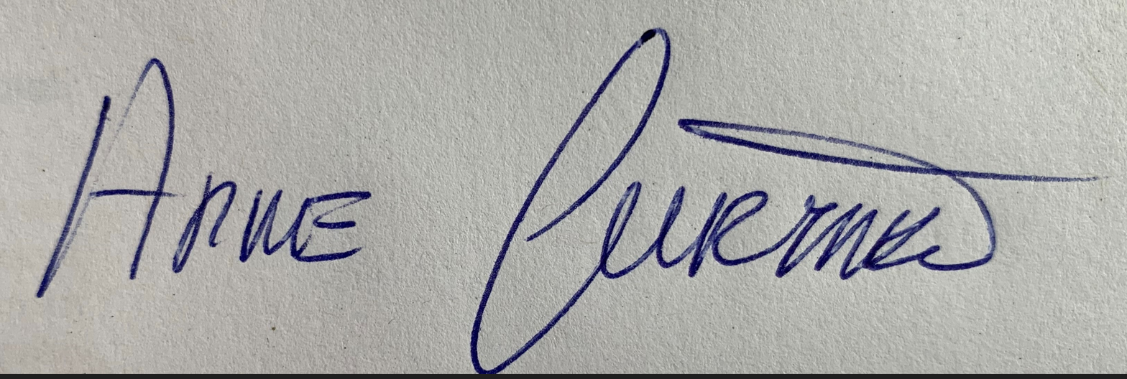

Arne Gürtner
Senior Vice President
Chair of Equinor UK Ltd

