

ESTIMATES MEMORANDUM
DEPARTMENT OF HEALTH AND SOCIAL CARE
2022-23 MAIN ESTIMATE

TABLE OF CONTENTS

- Overview 3
1.1 Objectives 3
1.2 Spending Controls 3
1.3 Main Areas of Spending 4
1.4 Comparison of Spending Totals Sought 6
1.5 Key Drivers of Spending Changes Since Last Year 6
1.6 New Policies and Programmes 7
1.7 Spending Trends 7
1.8 Funding: Spending Review and Budgets and other spending announcements 10
- Spending Detail 11
2.1 Resource DEL 12
2.2 Capital DEL 12
2.3 Resource AME 13
2.4 Ring Fenced Budgets 13
2.5 Changes to Contingent Liabilities 14
- Priorities and Performance 15
3.1 Major Projects 15
- Other Information 16
4.1 NHS England 16
4.2 DHSC Inter-Group Transactions 17
4.3 DHSC Resource Expenditure Analysis 18

- OVERVIEW

  - Objectives
The Department of Health and Social Care (DHSC) supports ministers in leading the nation’s health and social care to help people live more independent, healthier lives for longer.

Departmental priorities are summarised below:

- Protect the public’s health through the health and social care system’s response to Covid-19;
- Improve healthcare outcomes by providing high-quality and sustainable care at the right time in the right place, improving infrastructure and transforming technology;
- Improve healthcare outcomes through a supported workforce fit for the future;
- Improve, protect and level up the public’s health, including reducing inequalities; and,
- Improve social care outcomes through an affordable, high quality and sustainable adult social care system.

Please note updated objectives are to be published later in 2022-23

  - Spending Controls
DHSC’s spending is broken down into the different spending totals, for which Parliament’s approval is sought. The spending totals which Parliament votes are:

- Resource Departmental Expenditure Limit (Resource DEL) – day to day running costs;
- Capital Departmental Expenditure Limit (Capital DEL) – investment in infrastructure;
- Resource Annually Managed Expenditure (Resource AME) – non-fiscal less predictable expenditure, in DHSC’s case this is mainly litigation provisions for clinical negligence cases managed by NHS Resolution (NHSR); and
- Capital Annually Managed Expenditure (Capital AME) – in DHSC’s case this covers the specific budgeting treatment relating to IFRS16.

In addition, Parliament votes a net cash requirement, designed to cover the elements of the above budgets which require the DHSC Departmental group to pay out cash in year.

  - Main Areas of Spending
The graphics below show the main components of DHSC’s proposed Resource DEL, Capital DEL and Resource AME spending plans, included in the latest Main Estimate, and the proportions spent by the different bodies within the group. The letters in the graphics below denote the letter attributed to each Estimate Subhead.

Further details are included in paragraphs 1.8 and 2.1.

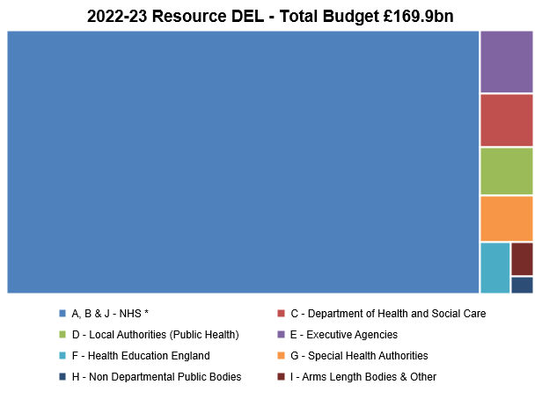
* NHS – this section represents the funding available for the NHS and consists of the following Estimate lines:
A – NHS Commissioning Board (known as NHS England);
B – NHS Providers; and
J – NHS Commissioning Board (known as NHS England) net expenditure financed from National Insurance Contributions.
Details of the spending plans for each Estimate line can be found in section 2.1.
Please note the core funding for NHS Improvement (NHS TDA and Monitor) is not currently included in the *NHS funding block above. Instead it is included in block G (NHS TDA) and block H (Monitor).

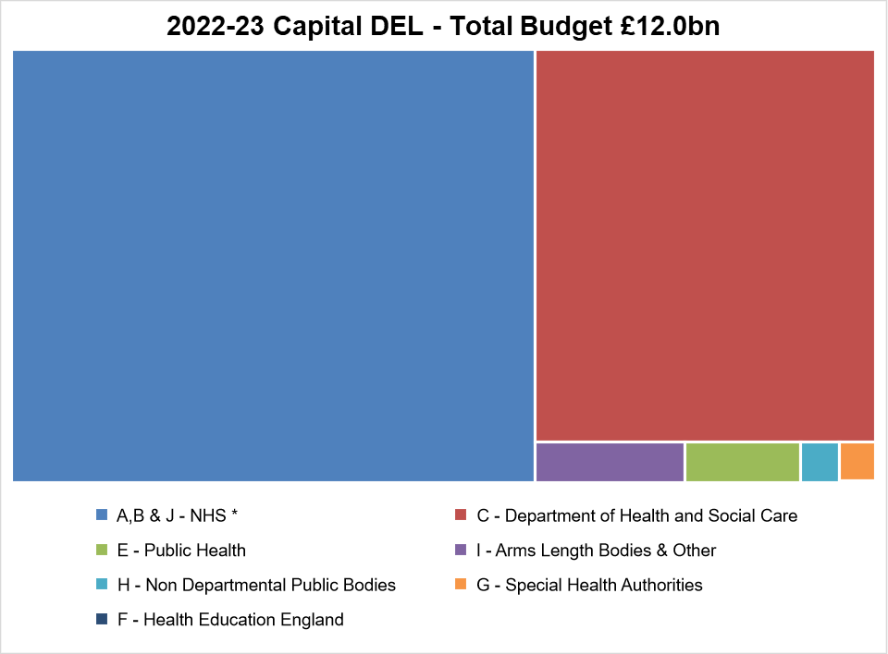
Please note the capital for Health Education England (line F) is not shown in this illustration due to relatively small size of the budget (£2m). Details of the spending plans for each Estimate line can be found in section 2.1.

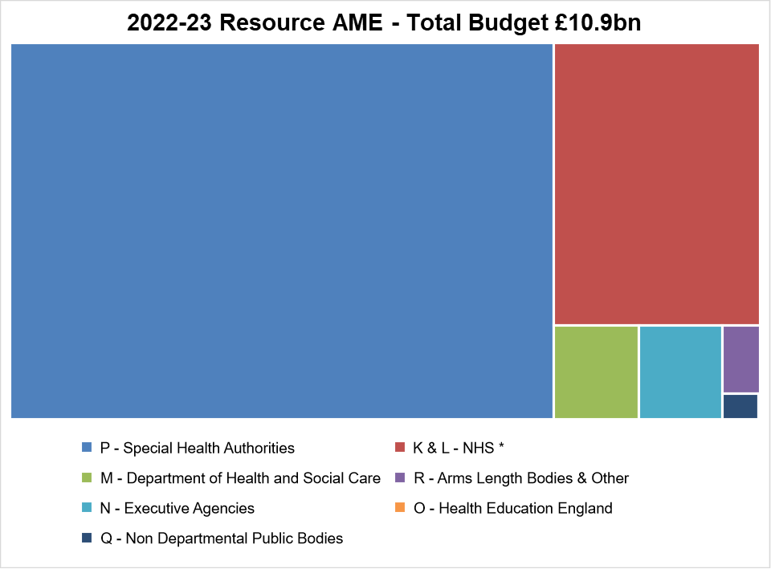

  - Comparison of Spending Totals Sought
The table below shows how the 2022-23 Main Supply Estimate spending plans compare with the 2021-22 Supplementary and Main Estimates.

DEL Type | 2022-23 Main Estimate | 2021-22 Supplementary Estimate | Variance to  2021-22 Supplementary Estimate |  | 2021-22 Main Estimate | Variance to  2021-22 Main Estimate
DEL Type | £m | £m | £m | % | £m | £m | %
Resource DEL | 169,948 | 186,895 | (16,948) | -9.1% | 177,815 | (7,867) | -4.4%
Capital DEL | 12,048 | 10,447 | 1,601 | 15.3% | 8,530 | 3,518 | 41.2%
Resource AME | 10,880 | 49,000 | (38,120) | -77.8% | 10,002 | 878 | 8.8%

  - Key Drivers of Spending Changes since last year:
This section identifies the key drivers of change since last year for Resource DEL, Capital DEL and Resource AME. Further detailed analysis of changes can be found in section 2.

Resource DEL - The changes in resource DEL in 2022-23 compared to 2021-22 are detailed in the table and explanations below:
Explanation of changes - £bns | 2022-23 Main Estimate | 2021-22 Supplementary Estimate | 2022-23  change
Resource DEL (excl depreciation) - per SR21 (a) | 167.9 | 147.1 | 20.8
Covid funding (b) |  | 39.2 | (39.2)
Other (c) | 2.0 | 0.6 | 1.4
Resource DEL - per Main Estimates | 169.9 | 186.9 | (16.9)

- Resource DEL SR21: a circa £21 billion increase in DHSC Group funding for 2022-23 as published in Spending Review 2021, supported by revenue raised from the Health and Social Care Levy, to provide the NHS with resources needed to tackle COVID-19 and the elective backlog where patients need non-emergency tests or treatment.
- Covid: the 2021-22 Supplementary Supply Estimate included reserve claim funding of £39.2 billion explicitly for Covid-19. As detailed above, SR21 has made provision for Covid-19 over the spending review period.
- Other: includes funding for depreciation and transfers to/from other government departments.

Capital DEL The changes in resource DEL in 2022-23 compared to 2021-22 are detailed in the table and explanations below:
Explanation of changes - £bns | 2022-23 Main Estimate | 2021-22 Supplementary Estimate | 2022-23  change
Capital DEL - per SR21 (a) | 10.4 | 9.4 | 1.0
Covid funding (b) |  | 1.2 | (1.2)
Other (c) | 1.6 | (0.2) | 1.8
Capital DEL - per Main Estimates | 12.0 | 10.4 | 1.6

- Capital DEL SR21: a circa £1 billion increase in DHSC Group funding for 2022-23 as published in Spending Review 2021.
- Covid: the 2021-22 Supplementary Supply Estimate included reserve claim funding of £1.2 billion explicitly for Covid-19.
- Other: mainly includes funding for IFRS16 – detailed further at paragraph 1.8
Resource AME is around £38 billion lower in 2022-23 as 2021-22 included funding for the change in the discount rate prescribed by HM Treasury in 2020-21 to measure the value of long-term provisions liabilities.

  - New Policies and Programmes
The DHSC makes all announcements on new policies and programmes during the year on the government website, details can be found at DHSC announcements.

  - Spending Trends
The graphs show the outturn for the last 3 years (2018-19 to 2020-21), plans presented in Supplementary Estimates for 2021-22, and future spending plans for the Spending Review 21 period for Resource DEL, Capital DEL and Resource AME.

- Resource DEL

NHS Long Term Plan
Increases from 2019-20 include the multi-year funding commitment announced by the Prime Minister in June 2018 and the NHS Long Term plan, published in January 2019. More details can be found at NHS Long Term Plan implementation.

2020-21
In 2020-21, DHSC incurred £42.9 billion resource expenditure on the emergency response to Covid-19. Details of the Covid-19 programmes this was incurred on are detailed in the 2020-21 Annual Report and Account.

2021-22
The 2021-22 Supplementary Supply Estimate (SSE) budget was based on funding announced in the 2020 Spending Round, the additional funding announced in the 2021 Spring Budget and the additional funding agreed in the SSE. This included Covid-19 funding of £39.2 billion comprising:
- £16 billion for NHS Test and Trace;
- £13.7 billion to fund the NHS’s recovery from the impact of Covid-19, to deal with both the continuing COVID-19 pressures and recover routine services affected by the pandemic.
- £2.7 billion for Covid-19 Vaccine deployment including Covid certification;
- £2.3 billion for the Covid-19 Vaccines Taskforce (VTF) to mainly cover the purchase of vaccines including booster doses, these score to the Resource DEL budget on consumption. The VTF funding includes a £695 million MOG transfer from BEIS;
- £2.4 billion for Personal Protective Equipment;
- £1.1 billion for Covid grants;
- £440 million for Covid-19 therapeutic treatments £440 million. This funding covers costs related to the use of Covid-19 treatments such as antivirals. These treatments score to Resource DEL on consumption.
- £329 million for the Managed Quarantine Service; and
- £150 million other Covid-19 £150m, for ventilators and critical care items.

Spending Review 2021
The DHSC Spending Review 2021 settlement included £167.9 billion resource funding for 2022-23, £173.4 billion in 2023-24 and £177.4 billion in 2024-25. This provided a £43.9 billion cash increase in resource spending from 2019-20.

The government remains committed to providing our health and care services with the future resources they need to tackle Covid-19 and the elective backlog. SR21 provided £9.6 billion over the period 2022-23 to 2024-25 for key Covid-19 programmes and related health spending, £5.4 billion for social care outcomes through an affordable, high-quality and sustainable adult social care system and set out plans to spend over £8 billion during the same period for the elective backlog. This will be backed by the new Health and Social Care Levy.

- Capital DEL
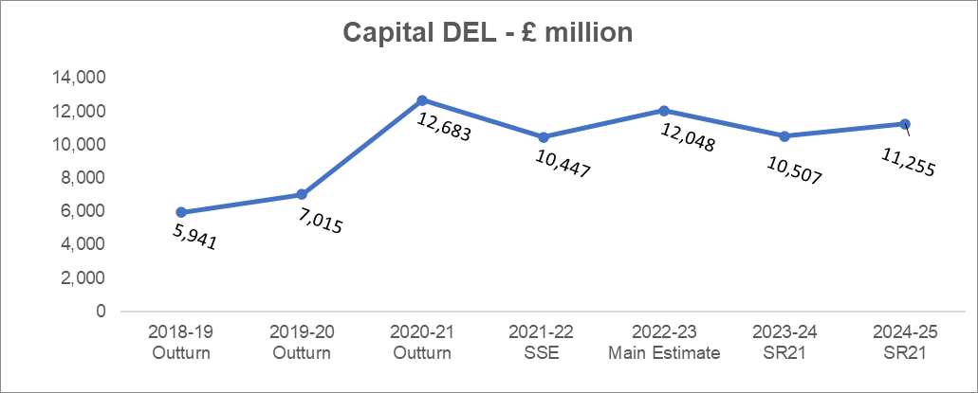
Please note, funding for IFRS16 (see paragraph 1.8) has not been included in 2023-24 and 2024-25

Spending Review 2020
Spending Review 2020 provided multi-year ring-fenced capital investment funding commitments of £3.7 billion until 2024-25 to make progress on building 40 new hospitals by 2030 and £1.7 billion until 2024-25 for over 70 hospital upgrades to improve health infrastructure across the country over the long term. These projects will span the length and breadth of England, supporting the government’s levelling up agenda.

2020-21
In 2020-21, DHSC incurred £3.6 billion capital expenditure on the emergency response to Covid-19. Details of the Covid-19 programme this was incurred on are detailed in the 2020-21 Annual Report and Account.

2021-22
The 2021-22 Supplementary Supply Estimate (SSE) budget was based on funding announced in the 2020 Spending Review, the additional funding announced in the 2021 Spring Budget and the additional funding agreed in the SSE. This included Covid-19 funding of £1.2 billion comprising:

- (£240) million for NHS Test and Trace (NHSTT) to cover the purchase of capital assets and net decreases in inventory. NHSTT’s inventory expenditure, in line with HM Treasury’s budgeting classification of large inventory purchases, incurs a charge to capital DEL on purchase and a charge to resource DEL with an equivalent credit to capital DEL on consumption.
£580 million for the NHS to tackle the elective backlog, to be used for extra theatre capacity and productivity-boosting technology, to increase the number of surgeries able to take place.
- £12 million for Covid-19 Vaccine deployment.
- £858 million for the Covid-19 Vaccines Task Force (VTF) to cover the costs of VTF that score to the capital budget following HM Treasury budgeting classification convention.
- £5 million for Personal Protective Equipment ; and
- £6 million for Covid-19 therapeutic treatments.

Spending Review 2021
The DHSC Spending Review 2021 settlement includes £10.6 billion Capital funding for 2022-23, £10.4 billion, for 2023-24 and £11.2 billion for 2024-25. This settlement includes capital investment to continue to improve the NHS infrastructure over the next three years, including:
- £2.3 billion to transform diagnostic services, taking us to a total of at least 100 community diagnostic centres (CDCs) across England to permanently increase diagnostic capacity and help patients receive lifesaving checks close to their homes;
- £2.1 billion for improving NHS technology and digital assets;
- £1.5 billion for new surgical hubs, increased bed capacity and equipment to help elective services recover, including surgeries and other medical procedures;
- £300million to replace outdated mental health dormitories with single rooms and an additional £150 million for investment in the wider mental health estate.

- Resource AME
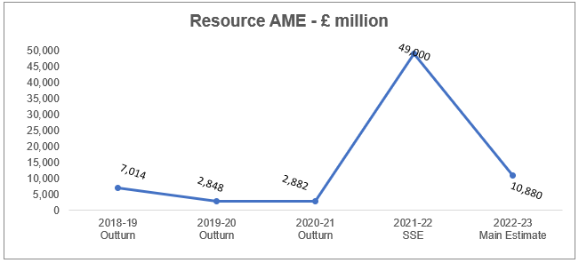
The Department’s AME doesn’t have an immediate impact on the fiscal framework. It relates to provisions and impairments that are demand-led, volatile and subject to many variables outside the Department’s direct control, such as changes to the discount rates to measure the value of long-term provisions liabilities. The £39 billion increase in the 2021-22 Supplementary Supply Estimate mainly relates to the estimated increase in the provision for clinical negligence claims, mainly due to the impact of the discount rate change.

  - Changes to 2022-23 Funding: Spending Review and Fiscal Events and other Spending Announcements
The Department’s 2022-23 spending plans were announced in the 2021 Spending Review, see paragraph 7.1 of the Government announcement in October 2021. Since that time, changes to 2022-23 spending plans include funding for IFRS16 implementation and budget cover transfers between DHSC and other government departments. A summary of the changes can be found below:

Main changes since 2021 Spending Review | RDEL  £m | CDEL  £m
2021 Spending Review (Resource DEL includes ring-fenced funding of £1.580bn) | 169,486 | 10,607
2022-23 Main Estimate (a) | -55 | 1,435
2022-23 Routine transfers of funding from other Government Departments (b) | 516 | 6
TOTAL | 169,948 | 12,048
- Budget adjustments for IFRS16 implementation: Government departments are required to implement the accounting standard for leases - International Financial Reporting Standard 16 (IFRS16). Full details were published by HM Treasury in December 2020. In simple terms there is no longer the distinction between operating leases (scored to resource) and finance leases (scored to capital), meaning that departmental budgets will change as follows:

- Capital: to include the costs of new leases and changes to existing leases. In 2022-23, DHSC’s IFRS16 capital funding is £1.4 billion.
- Resource: to include the depreciation costs and interest costs of leasing offset by the expense that would have been incurred under the previous leasing standard for operating leases. In 2022-23 DHSC’s IFRS16 resource funding is a reduction of £55 million
- routine transfers from other Government departments – RDEL £516 million and CDEL £6 million;
- SPENDING DETAIL

The tables below detail the changes in the 2022-23 Main Estimate compared to the 2021-22 Supplementary Supply Estimate. As per Estimates Memorandum convention, explanations for any changes, which are over both £10 million and 10% or over £200 million and 5% are provided in a referenced note under each table.

  - Resource DEL

The table below shows how DHSC’s 2021-22 Supplementary Supply Estimate spending plans for Resource DEL compare with the 2022-23 Main Estimate.

Subhead | Description | Resource
Subhead | Description | 2022-23 Main Estimate | 2021-22 SSE | Change from  2021-22 SSE |  | See Note 2.1
Subhead | Description | £m | £m | £m | %
A | NHS Commissioning Board (known as NHS England) net expenditure | 13,571 | 28,605 | (15,033) | -53%
B | NHS Providers | 97,285 | 96,075 | 1,210 | 1%
J | NHS Commissioning Board (known as NHS England) net expenditure financed from National Insurance Contributions | 41,735 | 25,197 | 16,538 | 66%
Sub Total - NHS |  | 152,591 | 149,877 | 2,715 | 2% | a)
C | DHSC programme and admin expenditure | 3,555 | 13,074 | (9,519) | -73% | b)
D | Local Authorities (Public Health) | 3,202 | 3,853 | (651) | -17% | c)
E | Executive Agencies | 4,149 | 12,725 | (8,576) | -67% | d)
F | Health Education England | 1,942 | 1,859 | 83 | 4%
G, H & I | Special Health Authorities, NDPBs and ALBs and Other Bodies | 4,508 | 5,507 | (999) | -18% | e)
TOTAL (Voted and Non Voted) |  | 169,948 | 186,895 | (15,949) | -9%

Estimate lines A, B and J represents the funding available to the NHS as detailed in section 1.3.

For estimate line A, NHS England, an explanation of how the estimate spending plans reconcile to the NHS England Mandate can be found in section 4.1.

- NHS: The change relates to increased funding as detailed in the Spending Review 21 offset by lower funding for Covid.
- DHSC Programme and Admin Expenditure: The change mainly relates to the reduction in funding for Covid.
- Local Authorities: The change relates to Covid grants included for 2021-22. More details on funding for 2022-23 can be found in the grants to Local Authorities publication.
- Executive Agencies: In 2022-23 this estimate line now includes the funding for DHSC’s two executive agencies; UK Health Security Agency (UKHSA) and Medicines and Healthcare Products Regulatory Agency (MHRA). The change between years mainly comprises the reduction of Covid funding between 2021-22 and 2022-23 and the inclusion of MHRA.
- Special Health Authorities, NDPB's and ALB's and Other Bodies: expenditure for these bodies varies year-on-year and the plans reflect the expected resource expenditure for these bodies.

  - Capital DEL
The table below shows how DHSC’s 2022-23 Main Estimate spending plans for Capital DEL compare with the 2021-22 Supplementary Supply Estimate.

Subhead | Description | Capital
Subhead | Description | 2022-23 Main Estimate | 2021-22 SSE | Change from  2021-22 SSE |  | See Note 2.2
Subhead | Description | £m | £m | £m | %
A | NHS Commissioning Board (known as NHS England) net expenditure | 219 | 279 | (60) | -22%
B | NHS Providers | 7,077 | 6,729 | 348 | 5%
J | NHS Commissioning Board (known as NHS England) net expenditure financed from National Insurance Contributions | 0 | 0 | 0 | 0%
Sub Total - NHS |  | 7,296 | 7,008 | 288 | 4% | f)
C | DHSC programme and admin expenditure | 4,302 | 2,912 | 1,390 | 48% | g)
D | Local Authorities (Public Health) | 0 | 0 | 0 | 0%
E | Executive Agencies | 153 | 48 | 104 | 217% | h)
F | Health Education England | 2 | 2 | 0 | 9%
G, H & I | Special Health Authorities, NDPBs and ALBs and Other Bodies | 295 | 477 | (182) | -38% | i)
TOTAL (Voted and Non Voted) |  | 12,048 | 10,447 | 1,601 | 15%

- NHS: The change of £288 million mainly relates to change relates to increased funding as detailed in the Spending Review 21 offset by lower funding for Covid.
- DHSC Capital: The change of 1.4 billion is mainly due to IFRS16 – see paragraph 1.8
- Executive Agencies: The change of £104 million is mainly due to 2021-22 including negative capital funding for NHS Test and Trace. The funding in 2022-23 reflects the capital funding for both UKHSA and MHRA.
- Special Health Authorities, NDPB’s & Arm’s Length and Other Bodies: Capital expenditure for these bodies varies year-on-year and the plans reflect the expected capital expenditure for these bodies.

  - Resource AME
The table below shows how DHSC’s 2021-22 Main Estimate spending plans for Resource AME compare with the 2020-21 Supplementary Estimate. It should be noted that DHSC’s AME relates to provisions and impairments, which have no immediate impact on the fiscal framework.

Subhead | Description | Resource
Subhead | Description | 2022-23 Main Estimate | 2021-22 SSE | Change from  2021-22 SSE |  | See Note 2.3
Subhead | Description | £m | £m | £m | %
K | NHS Commissioning Board (known as NHS England) net expenditure | 250.0 | 150.0 | 100.0 | 67%
L | NHS Providers | 2,000.0 | 2,020.0 | (20.0) | -1%
Sub Total - NHS |  | 2,250.0 | 2,170.0 | 80.0 | 4% | J)
M | DHSC programme and admin expenditure | 310.0 | 350.0 | (40.0) | -11% | J)
N | Executive Agencies | 300.0 | 300.0 | 0.0 | 0%
O | Health Education England | 2.0 | 5.0 | (3.0) | -60% | J)
P, Q & R | Special Health Authorities, NDPBs and ALBs and Other Bodies | 8,018.0 | 46,175.0 | (38,157.0) | -83% | J)
TOTAL (Voted and Non Voted) |  | 10,880.0 | 49,000.0 | (38,120.0) | -78%

The Department’s AME relates to provisions and impairments that are demand-led and volatile, being subject to many variables outside the Department’s direct control.

- The AME budget of £49 billion in the 2021-22 Supplementary Supply Estimate is due to the change in the discount rates, prescribed by HM Treasury in 2020-21 to measure the value of long-term provisions liabilities. The largest of DHSC provisions is the clinical negligence scheme provisions. The discount rate change did not reflect an increase in the incidence of harm or an increase in the cash required to settle claims.

  - Ring Fenced Budgets
Within the totals, the following elements are ring fenced i.e. savings in these budgets may not be used to fund pressures on other budgets.

DEL Type | 2022-23 Main Estimate | 2021-22 Supplementary Supply Estimate (SSE) | Variance to  2021-22 SSE |  | 2021-22 Main Estimate | Variance to  2021-22 Main Estimate
DEL Type | £m | £m | £m | % | £m | £m | %
ODA Total | 241 | 160 | 81 | 51% | 160 | 81 | 51%
EU Exit | 0 | 80 | (80) | -100% | 95 | (95) | -100%
Counter Terrorism Total | 106 | 0 | 106 |  | 0 | 106

- Official Development Assistance (ODA) - For international comparability and consistency, the Organisation for Economic Co-operation and Development (OECD) and the Development Assistance Committee (DAC) requires ODA reporting to be on a cash and calendar year basis.
- EU Exit - DHSC was allocated £95 million for EU Exit related spend for 2021-22 at Main Estimates this was based on the expected impact of exiting the EU at that point in time. Savings of £15 million were surrendered at Supplementary Supply Estimate. DHSC does not have ring-fenced funding for EU Exit in 2022-23.

- Counter Terrorism - DHSC has been allocated £106 million for counter terrorism. This is a new ring-fence for the Spending Review 21 period

  - Changes to Contingent Liabilities
There are no updates to contingent liabilities in the 2022-23 Main Estimate. Contingent liabilities will be published in the DHSC 2021-22 Annual Report and Accounts, these will be reflected in the 2022-23 Supplementary Supply Estimate.

- PRIORITIES AND PERFORMANCE

  - How Spending Relates to Objectives
See section 1.1.

  - Measures of Performance against each Priority
The Department’s priorities for 2022-23 are detailed in paragraph 1.1.

The Department’s 2020-21 Annual Report and Accounts details how 2020-21 expenditure related to 2020-21 strategic priorities.

Information on 2021-22 expenditure relating to 2021-22 priorities will be published in the 2021-22 Annual Report and Accounts.

The NHS Outcomes Framework (NHSOF) is a set of indicators developed to monitor the health outcomes of adults and children in England. The Framework provides an overview of how the NHS is performing. The NHSOF comprises five domains: preventing people from dying prematurely, enhancing quality of life for people with long-term conditions; helping people to recover from episodes of ill-health or following injury; ensuring people have a positive experience of care; treating and caring for people in a safe environment and protecting them from avoidable harm.

More information can be found on the NHS Digital website at Link to NHS Outcomes Framework.

  - Major Projects
The DHSC has several major projects which are financed from Resource and Capital DEL. Details of the project aims, Departmental commentary on actions planned or taken and timescales for implementation can be found at DHSC Government Major Projects Portfolio data 2020.

- OTHER INFORMATION

  - NHS England
The resources made available to NHSE in 2022-23 are set out in the Financial Directions to the Mandate to be published in March 2022. The figures in the 2022-23 Parliamentary Estimate will not reconcile to those in the Financial Directions for the following reasons:

- In line with HM Treasury Estimates conventions, figures are presented on a consolidated basis i.e. adjusted for intra-group trading transactions;
- NHSE expenditure is part-financed by non-voted National Insurance Contributions; and
- A number of small changes were included in the 2022-23 NHSE Financial Directions after the figures had been pulled together for inclusion in the 2022-23 Main Estimates.
Link to the 2022-23 NHSE Financial Directions

The table below reconciles the NHSE 2022-23 Main Estimate provision to NHSE’s 2022-23 Financial Directions

Reconciliation between the Estimate and the Mandate |  | Resource | Capital
 |  | £m | £m
Total Mandate (sum of the below) |  | 152,766 | 219
Less:
a) | Transactions with other bodies within the group | 97,500
b) | NHSE net expenditure financed from National Insurance Contributions (non-voted) - Estimate line J | 41,735
c) | Timing difference | (40)
NHSE net expenditure - estimate line A |  | 13,571 | 219

  - DHSC Inter-Group Transactions
HM Treasury designates that Estimates are prepared on a consolidated basis, meaning that all intra-group transactions are removed.

Across Government, the DHSC ‘Internal Market’ of circa £95 billion is unique to the DHSC and adds an additional layer of complexity, as all inter-group trading needs to be eliminated on consolidation when preparing the DHSC Estimate. These mainly relate to transactions between NHS Commissioners and NHS Providers.

NHS Providers are not directly funded, instead they generate income to cover their spending via trading activity with Commissioners. Commissioners pay Providers for each patient seen or treated, considering the complexity of the patient's healthcare needs, under a national tariff system.

The DHSC takes a pragmatic approach and eliminates only the material transactions between Departmental group bodies. The table below illustrates how the funds flow between the different bodies within the DHSC Group.
Estimate Line |  | Before Consolidation | ELIMINATIONS |  |  |  |  |  | Consolidated
 |  | Before Consolidation | NHSE with Providers | Providers with SpHAs | HEE with Providers | Exec Agencies with DHSC | Providers with ALBs and Other Bodies | Providers with DHSC | Consolidated
 |  | £m | £m | £m | £m | £m | £m | £m | £m
A | NHS England | 111,071 | (97,500) |  |  |  |  |  | 13,571
B | NHS Providers | 95 | 97,500 | (2,485) | 3,200 |  | (871) | (154) | 97,285
C | DHSC | 4,301 |  |  |  | (900) |  | 154 | 3,555
D | Local Authorities (Public Health) | 3,202 |  |  |  |  |  |  | 3,202
E | Executive Agencies | 3,249 |  |  |  | 900 |  |  | 4,149
F | Health Education England | 5,142 |  |  | (3,200) |  |  |  | 1,942
G | Special Health Authorities expenditure | 541 |  | 2,485 |  |  |  |  | 3,026
H | Non Departmental Public Bodies | 495 |  |  |  |  |  |  | 495
I | Arm's Length and Other Bodies | 117 |  |  |  |  | 871 |  | 988
J | National Insurance Contributions | 41,735 |  |  |  |  |  |  | 41,735
TOTAL |  | 169,948 | 0 | 0 | 0 | 0 | 0 | 0 | 169,948
Please note – this table does not include the funding that flows to NHS Providers from the Public Health Grant, as that funding is allocated to Local Authorities (outside the DHSC Group)

  - DHSC Resource Expenditure Analysis
The majority of the DHSC’s budget is allocated to fund the NHS. Circa £105 billion of resource expenditure in the Departmental group sits in the NHS Provider sector, spent on staff costs, drugs and procurement of supplies and services to deliver healthcare. Other significant expenditure includes primary care (including general practice, dentistry, ophthalmology, pharmaceutical) and prescribing costs.

Further information on the NHS Provider sector can be found in the 2020-21 Provider consolidated accounts; and NHSE/NHSI now issue combined Board Reports.

The chart below shows the 2017-18 to 2020-21 resource expenditure broken down to show the material categories as per the DHSC Annual Report in the Departmental Group Summary tables (2.2 Expenditure and 2.3 Income) for the relevant financial year.

Resource expenditure increased from £134.6 billion in 2019-20 to £180.2 billion in 2020-21, circa £43.0 billion of this increase related to Covid-19 expenditure. Inventory costs scoring to the resource budget have been shown separately, however the rest of the Covid-19 expenditure is included within all of the other categories detailed within the chart.

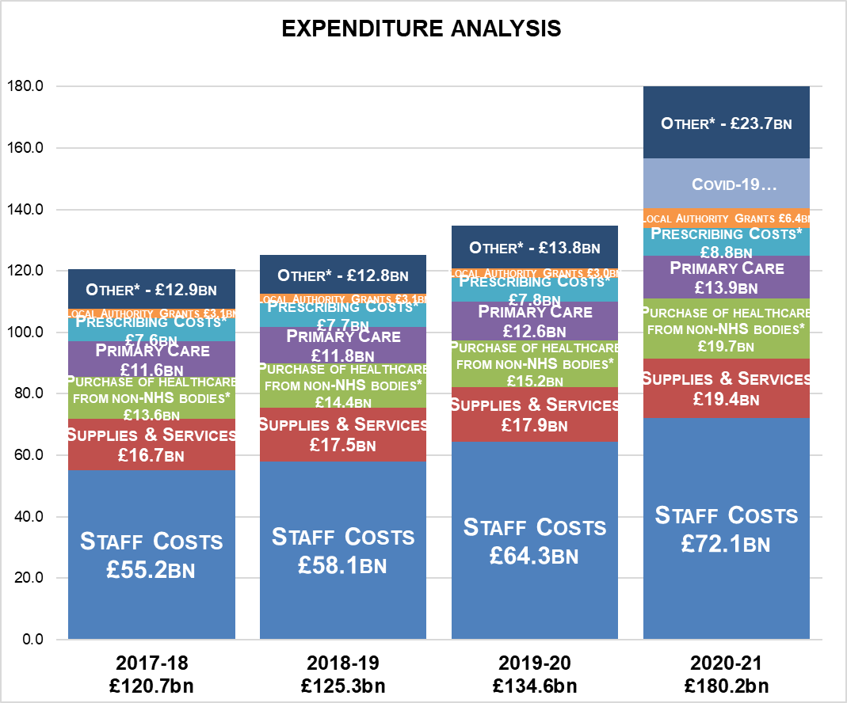

*These figures are net of income.

