

Letter to Parliamentarians (24 June 2022)

You have previously raised the discrepancy between the duties on search services and user-to-user services relating to fraudulent paid-for advertising in the Online Safety Bill.

We have listened to your feedback, along with feedback from stakeholders, and on 31st May 2022, the government tabled an amendment to address this. I am pleased to let you know that last week in the House of Commons at Committee stage, Parliament passed this amendment.

The amendment ensures the fraudulent advertising duty for Category 2A services will match the strong duties on large, high-risk user-to-user services in the Online Safety Bill, to ensure consistent outcomes between search and user to user services.

The amendment will require the largest search services to use proportionate systems and processes to: prevent individuals from encountering fraudulent advertisements; minimise the length of time that fraudulent advertisements are present; and, once alerted, to swiftly take down fraudulent advertisements. This change will ensure search engines prevent individuals encountering fraudulent advertising and will make it harder for fraudsters to advertise scams online via search services.
Failure to live up to these duties will be enforced by Ofcom who will have a range of robust powers to ensure that UK users are protected from online fraud.
Thank you for your continued work on this issue.
I look forward to working with you as the Bill progresses through the House.
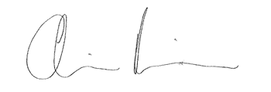

Chris Philp
Minister for Tech and the Digital Economy

