Paul Scully MP
Parliamentary Under-Secretary of State for Small Business, Consumers and Labour Markets
Department for Business, Energy and Industrial Strategy
1 Victoria Street,
London

26 June 2020
Dear Paul,
I am writing further to the Government’s response (26 June 2019), to the BEIS Committee’s Report – The safety of electrical goods in the UK: follow-up (HC 156; 29 October 2019). Though we welcome your response to a number our predecessor Committee’s recommendations, we are disappointed in terms of the urgency with which you intend to follow them up. We also have a number of questions regarding your responses, and I have set these out below:
1. You state that you have reviewed lessons learnt from the recall of Whirlpool’s tumble dryers (paragraph 12). Please can you confirm when this review will be published?
2. You note that the Office for Product Safety and Standards (OPSS) requires Whirlpool to provide weekly data updates to OPSS on the progress of the tumble dryer recall (paragraph 18). Please can you confirm whether Whirlpool’s data includes regular updates on the number of modified tumble dryers catching fire and, if so, how many have caught fire?
3. You state that the evidence OPSS has gathered so far does not suggest that any action is required regarding Whirlpool’s modification of its tumble dryers (paragraph 32). Can you confirm whether you have received additional reports other than from Whirlpool on problems with the modification and, if so, how many have caught fire and what the threshold is to review the modification again?
4. We welcome Whirlpool’s increased transparency and its actions regarding its defective tumble dryers and washing machines (paragraphs 19 to 22). However, bearing in mind that the predecessor Committee identified that there could be up to 850,000 defective tumble dryers in circulation along with hundreds of thousands of defective washing machines, what are the OPSS’s estimates of the number of tumble dryers and washing machines that still need to be replaced or modified?
5. We welcome OPSS’s closer cooperation with the London Fire Brigade (LFB) (paragraphs 27 to 30). Can you confirm when the OPSS will publish the Memorandum of Understanding with the LFB and details of how the OPSS is working with the LFB to improve data collection systems on incidents of domestic fires. Can you also confirm that fire safety services have access to a full working version of the Product Safety Database (paragraph 41)?
6. We welcome that the OPSS is working with relevant industry representatives to develop and promote clear guidance on the appropriate use of non-disclosure clauses and that guidance will be published in due course (paragraph 38). Please can you tell me when this guidance will be published and whether it will be placed on a statutory footing?
7. You have not addressed the funding of Local Trading Standards (LTS) in you response (paragraphs 42 to 47). Our predecessor Committee raised the problem of LTS funding not being ring-fenced in both the Report published last October but also in its orginal report published in January 2018 (The Safety of Electrical Goods in the UK, (HC 503; 16 January 2018)). Without proper funding LTS will struggle to provide surveillance on the ground and provide robust oversight of Primary Authority relationships. I would urge you to reconsider this issue as a matter of urgency. Please can confirm whether you will review the funding of LTS?
8. Your response says that OPSS will continue to work with online platforms to ensure that they have “robust proactive and reactive approaches in place to protect consumers” (paragraph 49) and that your predecessor wrote to Amazon, Alibaba, eBay, Gumtree and Facebook to determine what steps they are currently taking to ensure that unsafe and non-compliant goods are not made available to consumers via their platforms (paragraph 50). Can you tell me what these “robust proactive” measures are and what resonpose you got from Amazon, Alibaba, eBay, Gumtree, Facebook ?
9. We are surprised that OPSS is still in the process of establishing what safeguards online platforms have in place in terms of the safety of the goods sold on them (paragraph 51), and it alarming that the sale of online electrical goods is to be subject to voluntary action by major online platforms (paragraph 52). However, you state that OPSS is conducting a review of product safety legislation to determine whether the existing legislative framework is adequate in light of the changes to traditional supply and distribution chains brought about by e-commerce (paragraph 52). Can you update me on the progress made so far and when you expect to bring forward proposals?
10. We are concerned that while you accept the thrust of a number of our recommendations your response is to commit to more reviews, consulations, stakeholder engagement and trials/pilots with no sense of when outcomes will be delivered. This includes:
- Indelible marking – a call for more evidence from stakeholders (paragraphs 68 to 71).
- National incident database – a pilot study working with RoSPA and several NHS units (paragraphs 72 to 74), reviewing all aspects of OPSS’s evidence re unsafe products (paragraph 75).
- Insurance industry and product safety incidents - initial discussions with the insurance industry to understand what evidence they hold re incidents (paragraph to 76).
- Recalls and product regsitration -further digital development work and research to understand how customers become aware of product recalls (paragraph 63) and engagement with AMDEA and more research on how customers register goods (paragraphs 64 to paragraph 66). The predecessor Committee recommended in both its reports on product safety for a one-stop-shop where customers could access recall information and register their goods.
- Sale of second-hand electrical goods – a project to gather evidence about how and where second-hand electrical products are being sold (paragraphs 53 to 56).
The late Lynn Faulds Wood raised many of these issues in her Independent Review published in Feruary 2015, while a range of stakeholders including the London Fire Brigade, Eletrical Safety First and Which? have consistently raised these matters. The OPSS itself has been up and running since January 2018. Please can you explain why more research, consultations and stakeholder engagement is required to establish problems which have already been identified and when solutions to each of the the above will actually be delivered and whether, in each case, legislation rather than voluntary actions will be actively considered?
11. We welcome the consulation on the future of the OPSS (paragraph 77). Your predeccessor told the Committee that such a consultation would consider whether the OPSS should be an arms-length body, on the lines of the Food Standards Agency. Please can you assure the Committee that this consultation will include consderation of putting the OPSS on an independent footing? It is esssential that the OPSS has the independence and space to provide oversight of product safety matters and can provide confidence and assurance to consumers. This will be especially important as the Government considers trade agreements where products safety will be an issue.
I would appreciate a response to this letter by 13 July 2020.
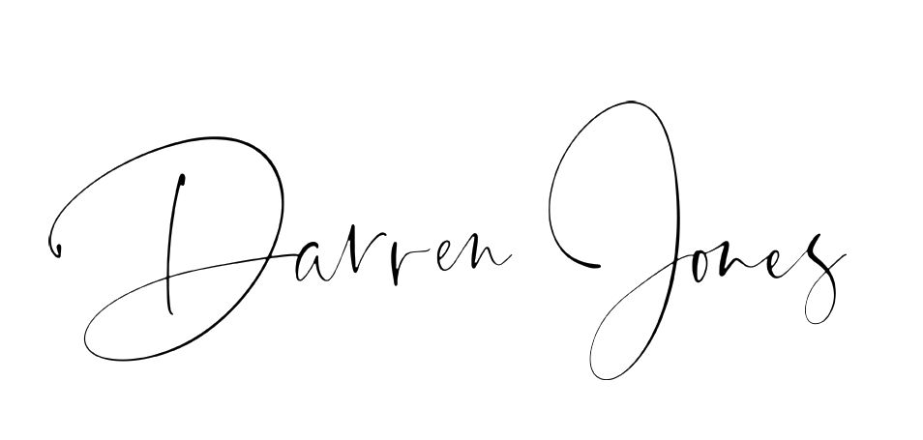
DARREN JONES MP
CHAIR OF THE BUSINESS, ENERGY AND INDUSTRIAL STRATEGY COMMITTEE

