Helen Pitcher OBE
Chairman
Criminal Cases Review Body

23 June 2020

Dear Ms Pitcher

Thank you for your letter of 3 June inviting the Justice Committee to conduct a “formal review of the circumstances and safeguards where an organisation is allowed, as the Post Office was in these cases, to act a prosecutor when it is also the victim and the investigator of an alleged offence”.

The Justice Committee has decided to undertake an inquiry titled: Private prosecutions: safeguards. The aim of the inquiry is to look into the specific issue you raised with us: to examine the safeguards in place to prevent injustices occurring in private prosecutions brought by organisations that act as the investigator and the prosecutor but are also the victim of the alleged offence.

We are conscious that a number of Post Office Horizon cases will be going before the courts in due course and that the Business, Energy Industrial Strategy (BEIS) Select Committee is undertaking an inquiry into the conduct of the Post Office. The Government has also announced an independent review to consider whether the Post Office “has learned the necessary lessons from the Horizon dispute and court case, and to provide an independent and external assessment of its work to rebuild its relationship with its postmasters”. We will ensure that our inquiry focuses on the specific question of whether the existing safeguards are sufficient and we will avoid any overlap with the aforementioned cases and inquiries.

To assist our enquiry, we would be grateful if you would consider submitting written evidence for our inquiry by 1 July. We have attached the inquiry’s terms of reference.

We look forward to your response.

Yours sincerely,
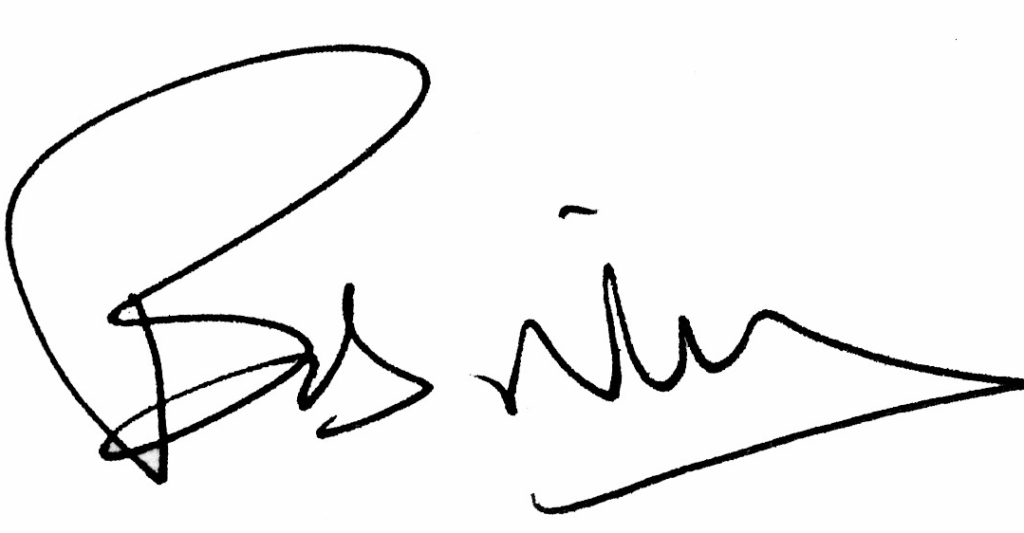

Sir Robert Neill MP
Chair
Justice Committee

