Impact of streaming on future of the music industry
AIE observations on DCMS Committee inquiry

We note with interest your inquiry into the impact of streaming on the future of the music industry examining what economic impact music streaming is having on artists, record labels and the sustainability of the wider music industry.
We like to draw your attention to the successful and more equitable alternative business model we have been operating in Spain for some 15 years. In a nutshell, music streaming services pay an additional amount for the music to us, the Spanish collecting society for musical performers, which we distribute to individual artists using our comprehensive databases. Our model is based on equitable remuneration for artists for music streaming. It has been recognised legally and practically. It does not interfere with any contractual arrangements between artists and record companies and record companies and streaming services respectively. It is separate and in addition to any such arrangements.
We hope you find our experience helpful and remain at your disposal should you require further evidence for your inquiry collecting, written or orally if considered useful.
Artistas Intérpretes o Ejecutantes, Entidad de Gestión de Derechos de Propiedad Intelectual (AIE) is the Spanish collecting society representing the interests of musical artists in all genres, including modern classical music , Latin and Flamenco, as well as Jazz and Pop/ Rock. We work closely with the Spanish collecting society for actors. Link to the English language version of our website: https://www.aie.es/en/. Through 98 reciprocal agreements with collecting societies in 57 countries we are part of an international framework of artists’ collecting societies; we operate at a global level. Our international reach is increasing in particular cooperating with Latin and South American artists associations.
Under Spanish copyright law, artists have an unwaivable right to equitable remuneration from the music streaming service which is subject to mandatory collective licensing. This applies when the artist has transferred their rights to the record companies. It is in addition and independent to the contractual arrangements between the artist and the record company. The relevant article is Article 108 of the Spanish copyright law.
In practice, AIE negotiates the tariffs for equitable remuneration for music streaming services on behalf of artists. We collect the money from music streaming services together with usage data, and after deducting administration fees (which are about 10%) we distribute the money transparently to Spanish and international (including British) artists based on our comprehensive databases.
This approach can be easily adopted in the UK by extending the established UK system for broadcasting and public performance to also cover music streaming (legally referred to as “making available to the public”). Under UK copyright law artists have an unwaivable right to equitable remuneration for broadcast and public performance which is subject to mandatory collective licensing. Artists and record companies share this equitable remuneration in equal parts. It is successfully administered by PPL, the UK collecting society representing artists and record companies. The main difference between the Spanish and the British approach is the scope of equitable remuneration: Under Spanish law music streaming is within the scope of equitable remuneration whilst under UK law pure music streaming, where the user selects a specific piece of music he wants to listen to at a certain moment in time - “making available to the public” - is expressly excluded from the scope of equitable remuneration. The co-existence of remuneration rights with exclusive rights is already commonplace in the UK, for instance regarding the fund for session musicians which guarantees 20% of revenues from sales of their recordings or the rental right, i.e. the right to receive remuneration from loaning a CD or a DVD from a library.
Broadcasting and general music sales are fading away and music streaming is becoming the main business model for consumers listening to music; the exclusion of music streaming from equitable remuneration in the UK disadvantages British artists. Most of them will not fairly benefit from the growth in music streaming, if at all. In our experience, the inclusion of music streaming ensures that artists benefit at least to some extent from the growth of music streaming. It applies to artists who concluded a contract with a record company – “featured artists” - the same way as it applies to artists who were engaged by the record company for instance to play the drums on a specific recording for a one off lump sum payment – “non-featured artists”. At a practical level, the introduction of an equitable remuneration right in 2006 in Spain has not necessitated changes to contractual arrangements. The same is true in 2020; the contractual arrangements remain unaffected.
In our experience, the Spanish approach, i.e. to apply equitable remuneration to music streaming, contributes considerably to the sustainability of the careers of Spanish artists. After all, without creators and artists there would not be a music industry. The inquiry refers to the Copyright Directive and whether an equivalent should be introduced into UK law. Article 18 is the relevant provision forcing European Union members to provide fair remuneration for authors and performers. We understand that the UK government has decided not to implement this Directive; consequentially, it is not forced to provide fair remuneration for authors and performers. We respectfully suggest that the UK government is free to change the law irrespective of European Union directives if it wants to sustain the careers of British artists. Equitable remuneration which applies to broadcasts, music streaming and public performances is expressly allowed in the relevant international copyright treaties. Legal analysis: https://papers.ssrn.com/sol3/papers.cfm?abstract_id=3684375
In 2019, one music streaming service alone contributed €1.2 million as equitable remuneration benefiting artists in Spain ensuring the sustainability of their careers. This money is not available for music streaming in the United Kingdom.
For further and more detailed evidence please visit the comprehensive description of the Spanish model https://www.payperformers.eu/post/spain-the-first-member-state-to-implement-the-remuneration-right-for-streaming.

• What are the dominant business models of platforms that offer music streaming as a service?

1) INTRODUCTION
The consumption of content has changed radically in the digital environment and music is the first and most affected. Since the beginning of the Internet, the business model of the music industry has experienced a revolution which affects all the rightsholders and agents involved.
Specifically, artists and authors are suffering the consequences of the new ways of exploitation of music, from which they do not obtain any remuneration or, if so, those amounts are not in accordance with the massive exploitation acts of fixed performances carried out through the online music services.

2) CONTEXT OF THE EXPLOITATION OF MUSICAL RIGHTS
The beginning of new online business models —firstly, the downloading and, secondly, the streaming— was the reaction to the illegal exploitation of music (peer to peer) and, since that moment, the industry has tried to keep the analogue or physical business model, transforming its value chain to maintain its status and, at the same time, increasing its value share .
The business models digital music were based on the right of making available to the public (article 8 of the WCT and articles 10 and 14 of the WPPT), in contrast with the right of distribution (article 6 of the WCT and article 8 of the WPPT) on which the physical sales was based.
Services such as iTunes, Google Play, eMusic or 7Digital, which will be analysed below, provide the possibility to buy an album or single in a digital format to be listened to through our mobile telephone, Tablet, MP3 player or computer.
In 2008, several digital music services offering music streaming were launched (such as Spotify or Deezer). This business models allow the user to access a vast catalogue of albums and songs (30-40 million songs).
These services are based on two concepts Freemium and Premium, as business models: «the basic is free, extra has a price». In the first case, income of the service arises from advertising; and in the second case, from the fees paid by the users of the services.
In the streaming music models, users do not acquire a product —tangible or intangible— but access a service which allows them to enjoy the music for a certain period of time.

3) ANALYSIS OF THE EXISTING BUSINESS MODELS
Types of online music business models with their most significant examples:
• MUSIC DOWNLOADING: iTunes, Google Play, Amazon Music, 7 Digital, eMusic.
• INTERACTIVE STREAMING SERVICES: Spotify, Apple Music, Deezer, Google Play Music, TIDAL, Prime Music.
• ONLINE RADIOS AND NON-INTERACTIVE STREAMING SERVICES: Pandora, Soundcloud, Last.fm, iHeart, Sirius XM… and non-interactive options of Spotify, Apple Music, Deezer, Google Play Music, TIDAL, Prime Music.
• SIMULCASTING: Los 40 (Spain), Radio Kiss Kiss (Italy), Cherie y Fun Radio (Francia), NHK FM (Japan), Mega 98.3 (Argentina), Olímpica Stereo (Colombia), 2DAY FM (Australia), Metro FM (South Africa), Kiis FM (USA.), etc.
• ONDEMAND VIDEO SERVICES: YouTube, VEVO.

DIGITALMUSIC MARKET: EXAMPLES OF PROVIDERS

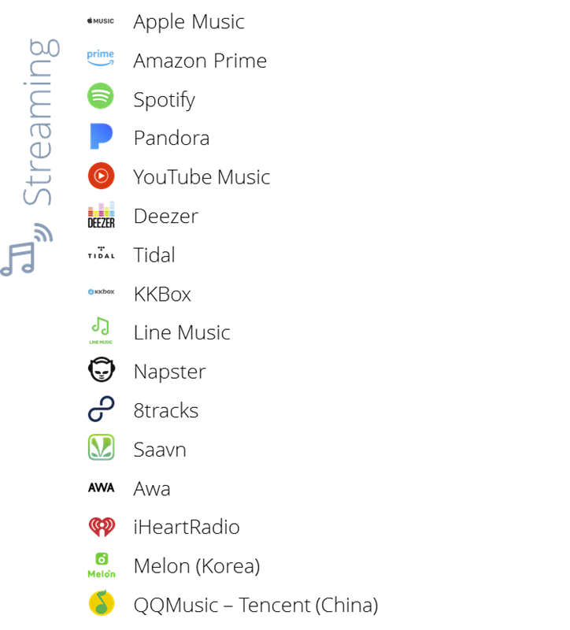
The differentiation between Streaming and Downloading does not represent the existing variety in terms of the business models of different providers. The differentiation impacts directly on the rights of performers (and their income). The model of exploitation and use of their music is the determining factor for performers. This is illustrated by SPOTIFY, as an example, which allows a variety of uses: fully interactive streaming, listening to stations and downloading content for offline listening.

BUSINESS MODELS: PROPOSAL OF VALUE

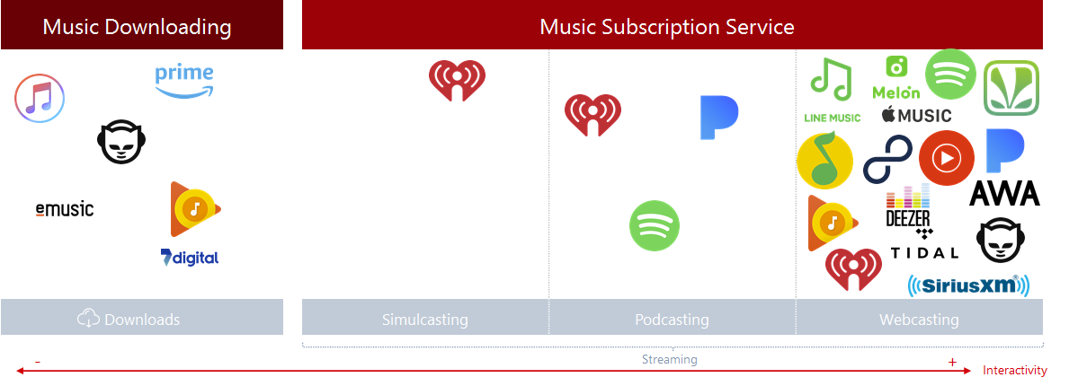

The evolution from music as a product that is acquired to a service that provides personalized access to content is the main change of recent years. In addition, the same provider often offers music in various ways.
- The download concept is incorporated into the service of many providers, but not linked to the purchase, but as part of the premium offers for offline access (Spotify, Pandora, Google Play Music, etc.).
- Music in podcasts appears as a Premium content that gradually replaces live linear radio (simulcasting).
- The relationship with the content (interactivity, sharing, follow, connect with social networks, etc.) depends on the type of subscription to the service (free, plus, Premium).

BUSINESS MODELS: CHANNELS

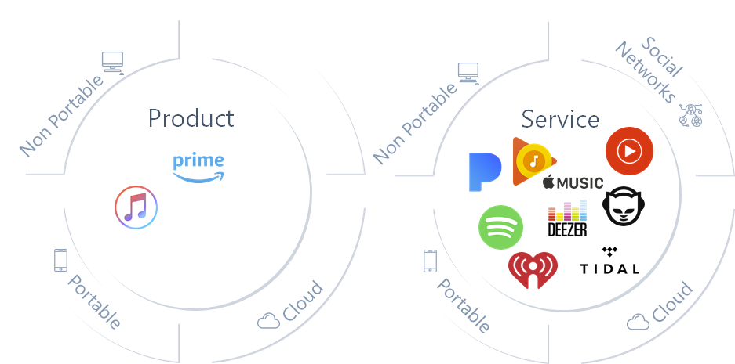

Existing technology allows the services to exactly adapt to the needs of the user. At present the offers combine full mobility with download capacity, programmed, or interactive reproduction, the connection with social networks, shared content storage, etc.

BUSINESS MODELS: STREAM OF INCOME

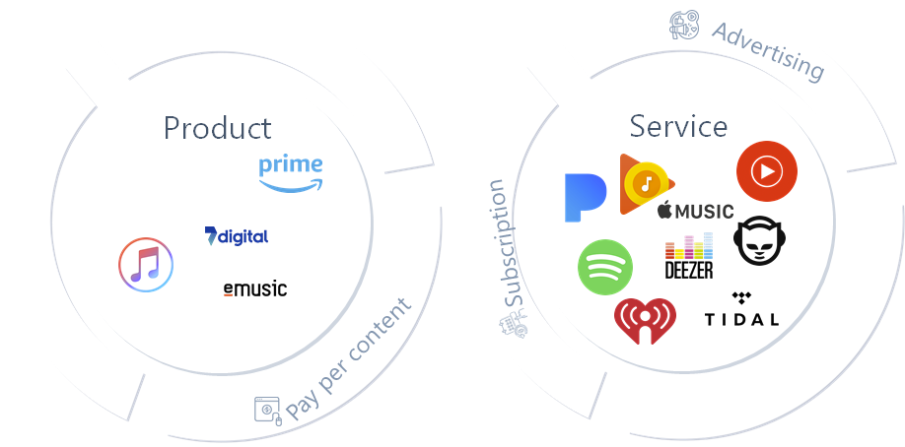

This graph explains the different revenue models in the market, based on either advertising as a source of financing for (free) subscriptions, or (full) paid for subscriptions. Most services offer a hybrid giving users the choice how they want to listen to music.
As to business models based on music as a Product, individual payment is the usual formula in music downloading and music acquisition services.
In contrast, music as a Service modality typically adopt a free advertising-based model, along with flexible subscription levels that allow more interaction with the content, without advertising.

MARKET SHARES IN THE MAIN PROVIDERS

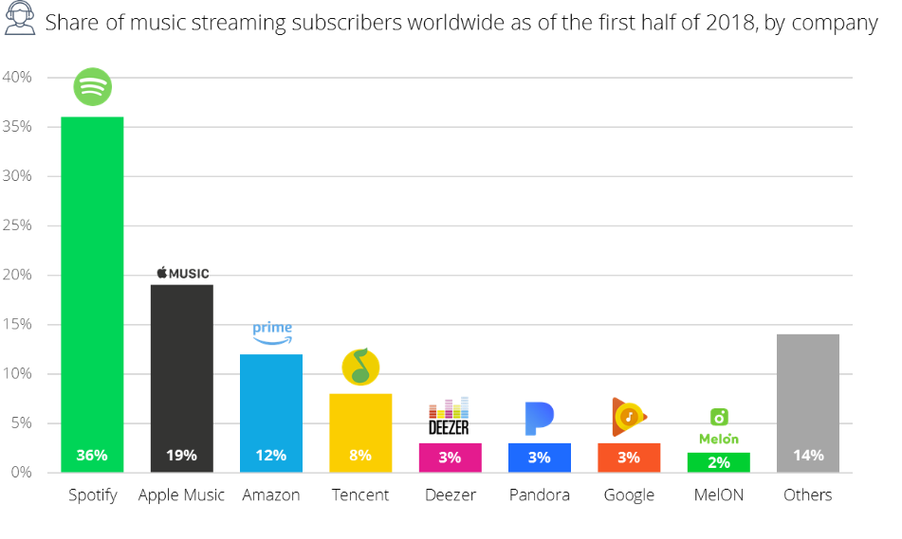

The infographic shows the market share by subscribers to streaming music services worldwide (Q2-2018). The market leader is Spotify with 36%, followed by Apple Music with 19%.

• Have new features associated with streaming platforms, such as algorithmic curation of music or company playlists, influenced consumer habits, tastes, etc?

1) INFORMATION ON THE HABITS OF CONSUMPTION OF USERS IN THE STREAMING PLATFORMS
According to certain studies on the use of digital platforms, 54% of the users of digital music platforms listen to music through playlists, thus displacing music albums released by recording companies.
Some digital music services are employing professionals to offer "human curation" of playlists as well as using artificial intelligence systems that allow them to organize their libraries of recordings, allowing consumers to quickly and easily find songs of their liking among the millions offered by the platform. As an example, SPOTIFY uses two types of playlists: on the one hand, those created by users and, on the other hand, those created by Spotify through curators or by "algorithms" created by its technicians.
We are very concerned about the new algorithm announced earlier this month enabling companies to pay for the promotion of their music; they just have to agree a pay cut from Spotify. This will invariably be at the expense of the artist.
2) STUDIES ON HABITS, USES AND CONSUMPTION IN SPAIN
In October 2017, the researching company CIMEC, specialised in market research strategy, conducted a study on the habits, uses and consumption of the Spanish population on streaming music, which was commissioned by the collective management organisation of performers in Spain (AIE).
This report, which could be applied to other countries and regions, concluded the following:

- Listening to music in streaming corresponds to 34% of the internet population in Spain, which entails —in absolute terms— an amount of 10.000.000 people.
- Much of the music consumption was made through conventional radio. It has been one of the main "victims" of the appearance of this new service (along with physical CDs and Internet downloads). In quantitative terms, it has been possible to verify that 62.7% of the current streaming users cite conventional radio as the main origin of the music they listened to before using a streaming service and that, nowadays, that figure accounts only to 45.4% of them (it represents a fall of 17 points). On the other hand, 37% of them listened to music through online radio before using streaming, while at present (after streaming became available), that figure has increased to 39.3%.
- Regarding the users who listen to streaming music, 53.1% of them just listen to music, and 46.9% of them interact with the Streaming Application.
- 52.3% of users choose Playlists already set up and, on the other hand, the remaining 47.7% search for specific songs, albums or specific singers.
- The most used Playlists are those made by the Platform itself (44.4% of those who usually use Playlists). They are used specially to discover new songs, styles and artists and to nourish the own Playlist with new contents. The following most used Playlists are their own ones (33.9%), those created by users based on their preferences and the music they discover autonomously or suggested by the Music Platform. They tend to be updated periodically. Afterwards, the lists made by other people (31.9%).

This study is conclusive, in the sense that the new consumption habits of music through streaming platforms have not only replaced music sales -physical and digital-, but they are the substitute for broadcasted radio as a mean to listen to music.
These modalities of exploitation of phonograms –ONLINE RADIOS- are non-interactive modalities of public communication that fall under the scope of the WIPO Treaties referring to the right of remuneration for communication to the public (see answers to next question).

• What has been the economic impact and long-term implications of streaming on the music industry, including for artists, record labels, record shops, etc?

THE EFFECTS OF THE NEW BUSINESS MODELS FOR PERFORMERS
In 2015, the income from digital exceeded —for the first time— the income arising from the physical sales, this tendency has been consolidated in the next years.
Regarding the production of music and its commercialization in the new digital market of streaming, the value chain has changed undoubtedly since digital technology has introduced many changes in the production and commercialization of music. In particular, the disruption of the value chain of physical production caused the disappearance of traditional agents (production of physical products, distribution logistic, physical storage...). This process of digitalisation in the industry has allowed the recording companies to extend their presence in respect of almost all the value chain, controlling all the process of production and increasing their position in the value chain. Consequently, the digitalization has provoked an imbalance in the distribution of value in relation to the physical production, affecting the income obtained by authors and performers in a negative way.
Despite of this change in the consumption of music by part of the users of these platforms and the change of the business model, the recording companies try to keep the economical and legal scheme related to the analogue business; they keep the licensing system, the royalties system and the agreements signed up to 50 years ago to dispose of the rights of performers.
Concerning recording companies, it is a business model of volume, they license their entire repertoire and obtain the vast part of the income (60-50%) accrued by the songs of their repertoires. However, it is a drama for artists since even those who have agreed royalties over the sales in their agreements see how the ratio of payment per stream is tiny and, despite of having great volume of listens, they do not obtain a remuneration reflecting the real use of their music.
The transfer of the rights and modalities of exploitation in the digital environment is seriously harming authors and performers if the traditional-analogue model is applied to new uses on the basis of a sale, while the streaming music models are closer to the model of rental: “access to a repertoire of phonograms in certain conditions”. A music stream is not a sale.
However, the legal scheme which fits in the view of the recording company is the one based on exclusive rights, which allows it to “collate ” rights to negotiate licenses including the biggest amount of rights (making available, communication to the public, reproduction….) and the biggest number of rightsholders (themselves, performers, authors…). This way they enjoy a strong bargaining power when negotiating the terms with the digital services.
Unlike the figures related to the sale of music —both physical and online—and the rating of piracy published by the IFPI on annual basis, they do not release the amounts obtained by the performers for the exploitation of their performances fixed in phonograms. However, it is clear that many artists (thousands), show their discomfort in an organized way (https://www.fair-internet.eu/es/) or individually (Taylor Swift, Beyoncé, Adele...) because of the low income from the massive reproduction of their songs through digital music services.
However, there are sources providing figures on the income and ratios obtained by performers per stream.
STREAMING SERVICE | STREAM/RATES | PRODUCER |  | ARTIST |  | BACK-UP MUSICIANS
YouTube | 0.00074$ | 90% | 0.00066$ | 10% | 0.000074$ | 0% | -
Pandora ^{(*)} | 0.00134$ | 50% | 0.00067$ | 45% | 0.000603$ | 5% | 0.000067$
Spotify | 0.00397$ | 90% | 0.00357$ | 10% | 0.000397$ | 0% | -
Google | 0.00611$ | 90% | 0.00549$ | 10% | 0.000611$ | 0% | -
Deezer | 0.00624$ | 90% | 0.00561$ | 10% | 0.000624$ | 0% | -
Amazon | 0.00740$ | 90% | 0.00666$ | 10% | 0.00074$ | 0% | -
Apple Music | 0.00783$ | 90% | 0.00704$ | 10% | 0.000783$ | 0% | -
Tidal | 0.01284$ | 90% | 0.01155$ | 10% | 0.001284$ | 0% | -
Napster/Rhapsody | 0.01682$ | 90% | 0.01513$ | 10% | 0.001682$ | 0% | -
Xbox Music | 0.02730$ | 90% | 0.02457$ | 10% | 0.00273$ | 0% | -

(*) Revenues from Pandora are managed by CMO´s and distributed to 50% between artists and producers).

We must take into account that the amounts obtained by performers from the exploitation of their rights online is based on the bargaining power of each artist when negotiating with the recording company, since —as we have shown and will developed below— the legal business is built on the transfer of the exclusive rights foreseen in the national legislations for performers, in this case, the making available to the public (as stated in the international Treaty for the rights of performers and phonogram producers the WPPT).
There are some sources referring to payments from each platform per stream in a global way, i.e., the royalty agreed with the artists is applied afterwards to obtain the actual income. Taking this into account, we can conclude that most of the performers do not obtain anything or obtain only tiny amounts.
THE STREAMING AS A SUBSTITUTE OF THE BROADCASTING
Nevertheless, the streaming music services not only affect the music sale market, but it is changing the habits of listening of radio consumer also, because these platforms offer, in addition to music on-demand, radio stations with which traditional terrestrial stations cannot compete, since these platforms are available to offer a great number of stations with a quality sound.
The modality of radio in the music platforms is based on acts of communication to the public of phonograms, different from those of making available, because the interactivity of these acts do not allow the user to choose the performances/phonograms to be accessed or do not allow the access in the moment chosen by the user because the platform selects the phonograms.
Regarding this modality of exploitation of phonograms, the right foreseen in the Article 12 of the Rome Convention and Article 15 of the WPPT applies. This right grants performers and producers of phonograms a right to obtain an equitable remuneration from those who carry out the acts of public communication.
However, the recording companies are reluctant to license this right and keep the scheme of licensing exclusive rights. In practice, it entails both the loss derived from the sale of digital music and the loss of income which, through the collective management organisations, they obtained from the broadcasting of their fixed performances. This transfer, in addition to the harm above mentioned, involves that performers lose any kind of negotiation position —direct or indirect— on their fixed performances, depending on the way to exploit them and the remuneration on the agreements reached with a third party —the recording company— in their own interest.
To summarize, in the current context of the exploitation of rights in the digital environment performers are the main victims of changes in business models and licensing practices, since the existing legal framework is insufficient and unable to balance the participation of all rights holders. In this sense, the streaming music models are the solution for the big recording companies and the ruin for thousands of performers. According to the available data:
- Revenues from digital services —since 2015— surpass those arising from business models based on physical media.
- Digital music services are not only replacing physical sales, but they also replace radio as the main means of listening to music. Music has ceased to be a product to become a service.
- In the scope of digital music services, the recording companies keep the business model and the remunerative scheme related to the sale of physical music.
- The right of remuneration for the public communication of phonograms shared by performers and producers, as of the 1961 Rome Convention, and specifically foreseen in the digital environment by article 15 of the WPPT, is being systematically infringed since the acts which fall under the right of public communication —other than making available acts—, and carried out by digital music platforms through their radio modalities and playlists, are not being managed collectively.

• How can the Government protect the industry from knock-on effects, such as increased piracy of music? Does the UK need an equivalent of the Copyright Directive?
From the point of view of a collective management organisation that manages performers’ rights, as AIE, the main problem to focus on is to enforce performers’ rights in the best possible way. For that, an adequate regulation and implementation is needed. As regards the digital environment, a fair share for performers must be ensured and the value gap that performers are enduring must be solved.
As explained in our introduction to the submission, although the UK government has decided not to implement the Copyright Directive, we respectfully suggest that an equivalent regulation be put in place to support British performers and ensure for them an equitable remuneration, collectively managed, for the use of their performances in the digital environment. The framework is established in article 18 of the Directive and the Spanish regulation is a practical experience from which British performers are already benefiting, when their performances are used in the Spanish territory.

• Do alternative business models exist? How can policy favour more equitable business models?
In our view, more than proposing alternative business models, it would be advisable that such business models recognise the real value brought by performers to the streaming services and their success. In that sense it would be necessary that such services share the value with performers in a balanced way.

In that sense, the Spanish system for equitable remuneration is an example of a fair regulation for performers. We report to the link provided in the introduction for a detailed information on the legal grounds of it. The system is helping to rebalance the distribution of value between all stakeholders in the industry without interfering on the position of digital platforms and producers; the combination of the negotiation power granted to collective management organizations, on behalf of all performers who are not able to negotiate directly with the platforms, and the un-waivable equitable remuneration collected for every digital use of their fixed performances is a successful one, to support performers in their careers in the future in the highly changing digital environment.

https://www.wipo.int/treaties/en/ip/wppt/
Source: Statista. April 2018
Data from “Annual Music Report – Streaming Forward Report 2018” de DIMA, page 3. http://www.midiaresearch.com/app/uploads/2018/04/DiMA-Streaming-Forward-Report.pdf
https://musically.com/2019/03/26/some-of-spotifys-programmed-playlists-will-now-be-personalised/
http://fortune.com/2018/08/10/spotify-playlist-pitching-curators/ https://www.rollingstone.com/music/music-news/how-spotify-playlists-create-hits-200277/
http://www.cimec.es/Index.html

