Rt Hon Rishi Sunak MP
Chancellor of the Exchequer
HM Treasury
Whitehall
London
SW1A 2HQ

13 May 2020

Dear Chancellor

The Coronavirus pandemic, as you will know only too well, has already had a significant impact on the Welsh and wider UK economy. To gauge the extent of this impact, we on the Welsh Affairs Committee have been undertaking an inquiry on The Welsh economy and Covid-19.

So that we can have a fuller understanding of the impact of the pandemic on the Welsh economy, we need data. In particular, we require the following information:

- The number of businesses in Wales which have received support as a result of the UK Government’s package of financial support schemes, including CBILS and the Bounce Back loan scheme;
- The number of businesses in Wales which have taken up the Coronavirus Job Retention Scheme to furlough employees, and the number of people in Wales who have been furloughed.
Due to the importance of this subject, we would appreciate the above data by 25 May.

Yours sincerely,

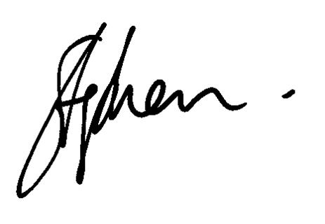
Rt Hon Stephen Crabb MP

